TOWN OF CLAREMONT
BUILDING CLASSES INFORMATION
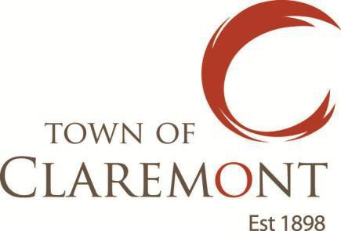

Class | Definition
Class 1 | A Class 1 building includes one or more of the following sub-classifications:  (1) Class 1a is one more buildings, which together form a single dwelling including the following;  (a) A detached house.  (b) One of a group of two or more attached dwellings, each being a building, separated by a fire-resisting wall, including a row house, town house or villa unit.  (2) Class 1b is one or more buildings which together constitute –  (a) a boarding house, guest house, hostel or the like –  (i) would ordinarily accommodate not more than 12 people; and  (ii) have a total area of all floors not more than 300 m² (measured over the enclosing walls of the building or buildings; or  (b) four or more single dwellings located on one allotment and used for short-term holiday accommodation.
Class 2 | A Class 2 building is a building containing two or more sole-occupancy units.  Each sole-occupancy unit in a Class 2 building is a separate dwelling.
Class 3 | A Class 3 building is residential building providing long-term or transient accommodation for a number of unrelated persons, including the following:  (1) A boarding house, guest house, hostel, lodging house or backpacker accommodation.  (2) A residential part of a hotel or motel.  (3) A residential part of a school.  (4) Accommodation for the aged, children, or people with disability.  (5) A residential part of a health-care building which accommodates members of staff.  (6) A residential part of a detention centre.  (7) A residential care building.
Class 4 | Class 4 is a dwelling in a Class 5, 6, 7, 8 or 9 building.
Class 5 | A Class 5 building is an office building used for professional or commercial purposes.
Class 6 | A Class 6 building is a shop or other building used for the sale of goods by retail or the supply of services direct to the public, including –  (1) an eating room, café, restaurant, milk or soft drink bar; or  (2) a dining room, bar area that is not an assembly building, shop or kiosk part of the hotel and motel; or  (3) a hairdresser’s or barber’s shop, public laundry, or undertaker’s establishment; or  (4) a market or sale room, showroom, or service station.
Class 7 | A Class 7 building is a storage type building that includes one or more of the following sub-classifications:  (1) Class 7a – a carpark.  (2) Class 7b – a building that is used for storage, or display of goods or produce for sale by wholesale.
Class 8 | A Class 8 building is a process-type building that includes the following:  (1) A laboratory.  (2) A building in which the production, assembling, altering, repairing, packing, finishing, or cleaning of goods or produce for sale takes place.
Class 9 | A Class 9 building is a building of a public nature that includes one or more of the following sub-classifications:  (1) Class 9a - a health care building including any parts of the building set aside as laboratories, and includes a health-care building used as a residential care building.  (2) Class 9b – an assembly building including a trade workshop or laboratory in a primary or secondary school  (3) Class 9c – a residential care building.
Class 10 | A Class 10 building includes one or more of the following sub-classifications:  (1) Class 10a is a non-habitable building including a private garage, carport, shed or the like.  (2) Class 10b is a structure that is fence, mast, antenna, retaining wall or free-standing wall or swimming pool or the like.  (3) Class 10c is a private bushfire shelter.
Multiple  Classifications | A building (or part of a building)must comply with all the relevant requirements that apply to each of the classifications for that building (or part of a building)

